.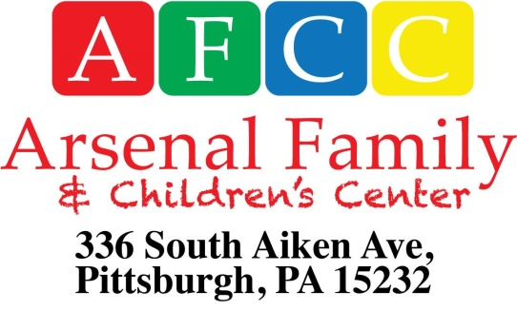

PLEASE PRINT
Preschool Program Registration 2018-2019 School Year
Child’s Name __________________________________________________Telephone#____________
Date of Birth: _______________________ Male __________ Female___________
Home Address: _______________________________________________ Zip Code_______________
Parent/Guardian________________________________________________
Address: ______________________________________________________Occupation_________________
Email Address: _________________________________________________Telephone#_________________
Parent/guardian ________________________________________________
Address: ______________________________________________________Occupation________________
Email Address: _________________________________________________ Telephone#________________
PROGRAM DESIRED (check one)
Half day 9am – 12pm Full Day 9am – 3pm
5 days (M-F) $510.00 /month $870 /month
3 days (M, W, F) $320.00 /month $540 /month
2 days (T, Th.) $230.00 /month $390 /month
Income-based scholarships are available for those families with a household income below $60,000.
Arsenal Family & Children’s Center does not discriminate in regards to race, religion, sex, or national origin.
Submit registration form with:
- Child’s Birth Certificate (Child must be 3 by September 30th)
- $20 non-refundable registration fee

